DIGITAL FORENSIC INVESTIGATION REPORT
Incident Summary:
Disk image: nps-2009-canon2-gen1.E01
Investigator: NABUKEERA JULIET
Date of Investigation: 2/4/2026
Subject of Investigation: Analysis of a digital image to identify suspicious activity, recover deleted data, and reconstruct a timeline of events.

- Introduction
Digital forensics is the process of collecting, preserving, analyzing, and presenting digital evidence in a legally acceptable manner. It plays a critical role in investigating cybercrimes, data breaches, and unauthorized system access.
This report presents a forensic investigation conducted using Autopsy, an open-source digital forensic tool. The purpose of the investigation was to analyze a forensic disk image, recover deleted files, examine user activities, and generate a structured forensic report.
- Methodology
The investigation followed a systematic forensic process to ensure accuracy and data integrity.
2.1 Tools Used
- Autopsy (Digital forensic analysis tool)
2.2 Steps Followed
- Installed and launched Autopsy
- Created a new forensic case
- Loaded a disk image file (.E01/.dd/.img)
- Performed file system analysis
- Recovered deleted files
- Analyzed web activity (browser history, downloads, cookies)
- Conducted keyword searches
- Used timeline analysis to reconstruct events
- Generated a forensic report
Autopsy is a premier open-source, GUI-based digital forensics platform used to analyze hard drives, mobile devices, and media to uncover deleted files, browser history, and user activity.
Key Features of Autopsy
Autopsy streamlines investigation by providing a centralized, efficient interface for tasks that would otherwise be done manually:
Timeline Analysis: Visualizes system events (file access, web history, login times) in a graphical interface to help investigators understand the chronological sequence of activity.
Keyword Search: Enables indexing and searching for specific terms, regular expressions, or patterns across the entire dataset to find relevant files.
Web Artifact Analysis: Automatically extracts browsing history, bookmarks, and cookies from browsers like Chrome, Firefox, and Edge.
Deleted File Recovery : Identifies and recovers deleted files from unallocated space using plugins like PhotoRec.
Hash Filtering & Lookup: Uses databases of known "good" files (e.g., system files) to ignore them, and "bad" files (e.g., malware, hash sets from NSRL) to flag them.
Registry Analysis: Utilizes tools like RegRipper to parse Windows registry files to uncover recently accessed documents, USB devices, and user activity.
Multimedia Analysis: Extracts EXIF data from JPEG images, providing geolocation and camera metadata.
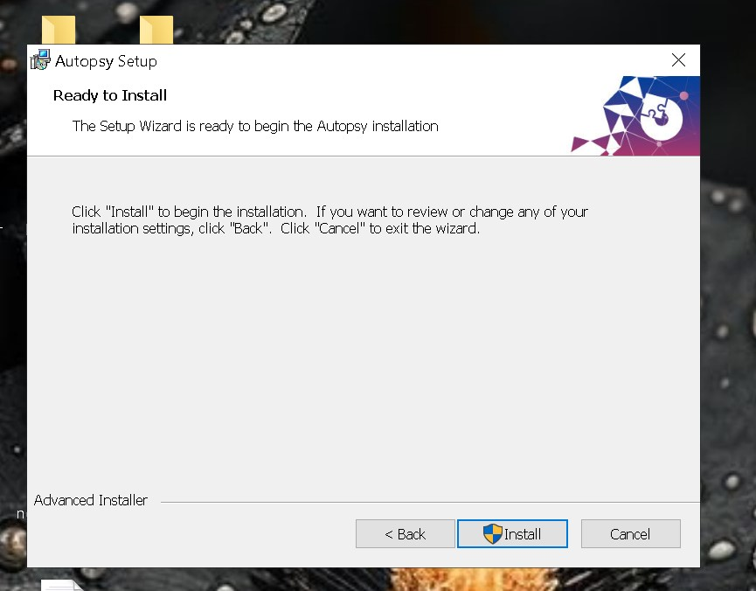
Multi-User Collaboration: Allows teams to collaborate simultaneously on large investigations.

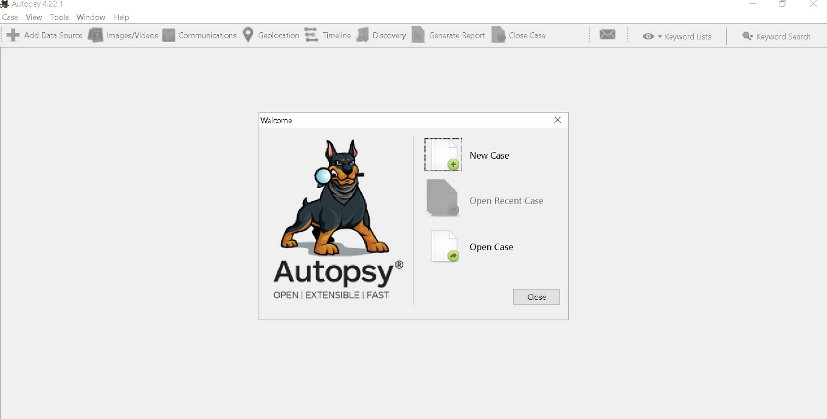

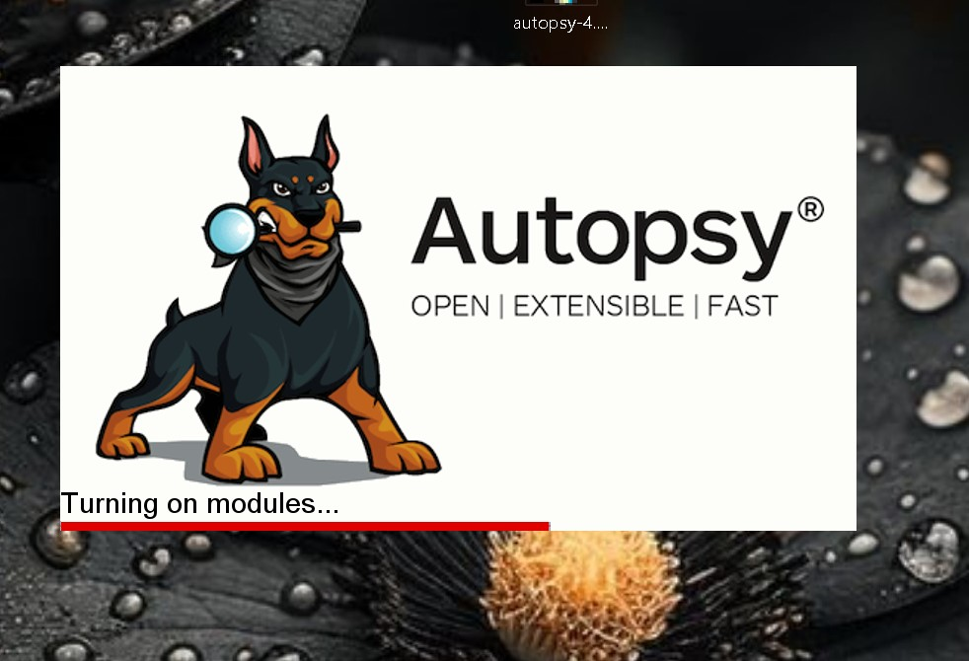

TASK 2:
A forensic image is an exact, bit-by-bit copy of a storage device (like a hard drive or phone), capturing all data including active files, deleted files, and unallocated space. It serves as a legally defensible snapshot of digital evidence, created using special tools that ensure the original media remains unaltered.
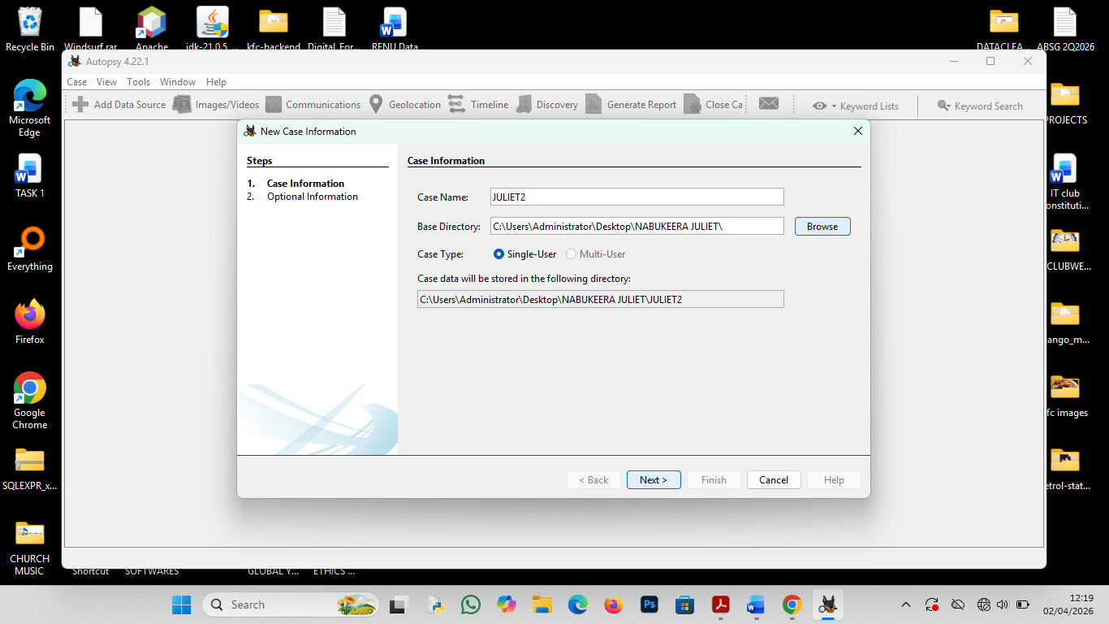
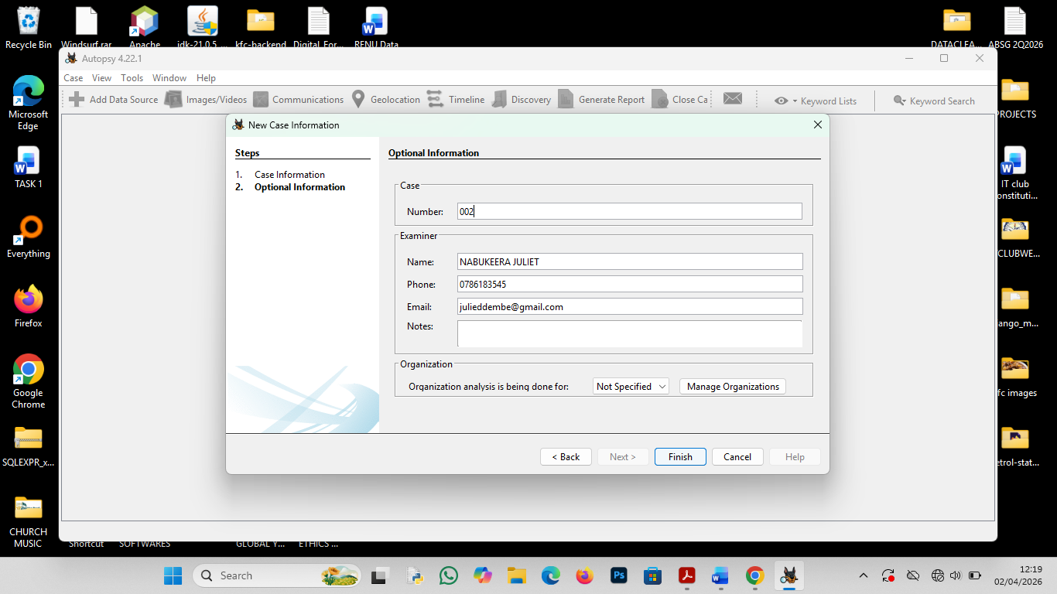
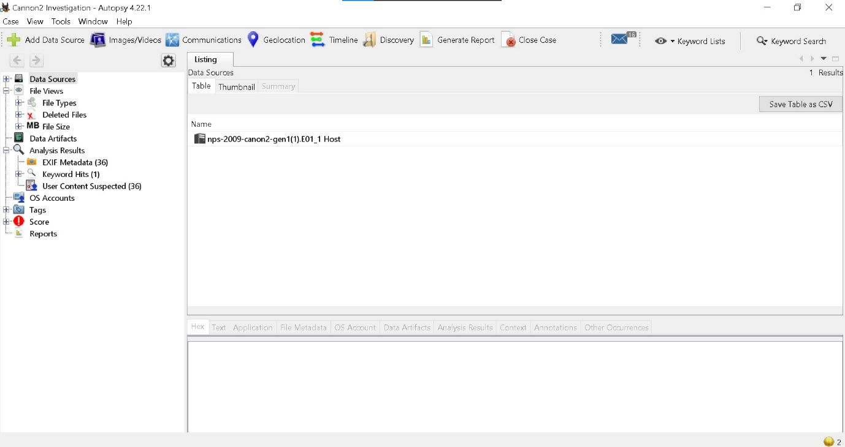

TASK 3:
FILE STRUCTURE
The directory tree was successfully mapped, allowing for a clear distinction between system-generated files and user-created data.
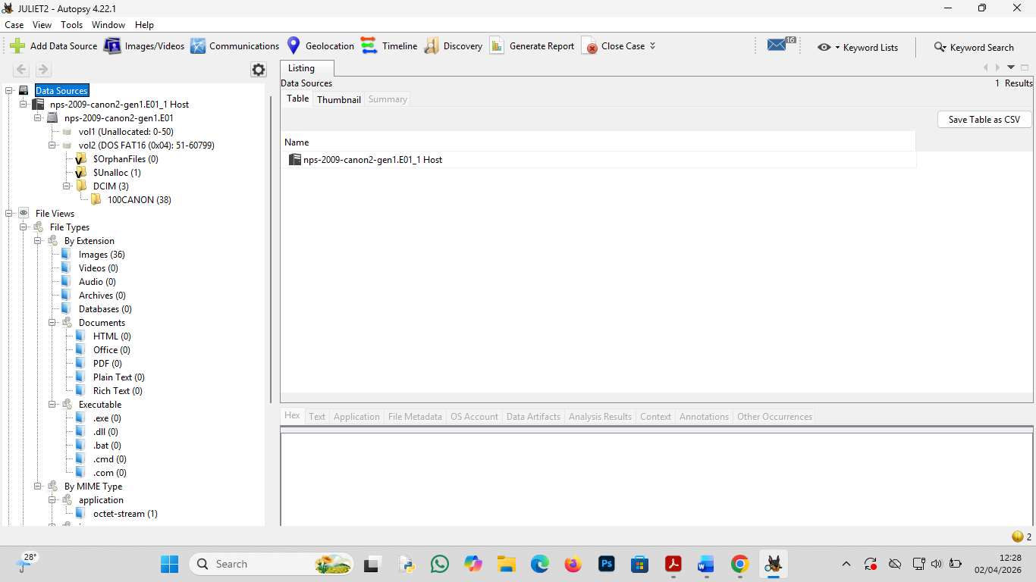

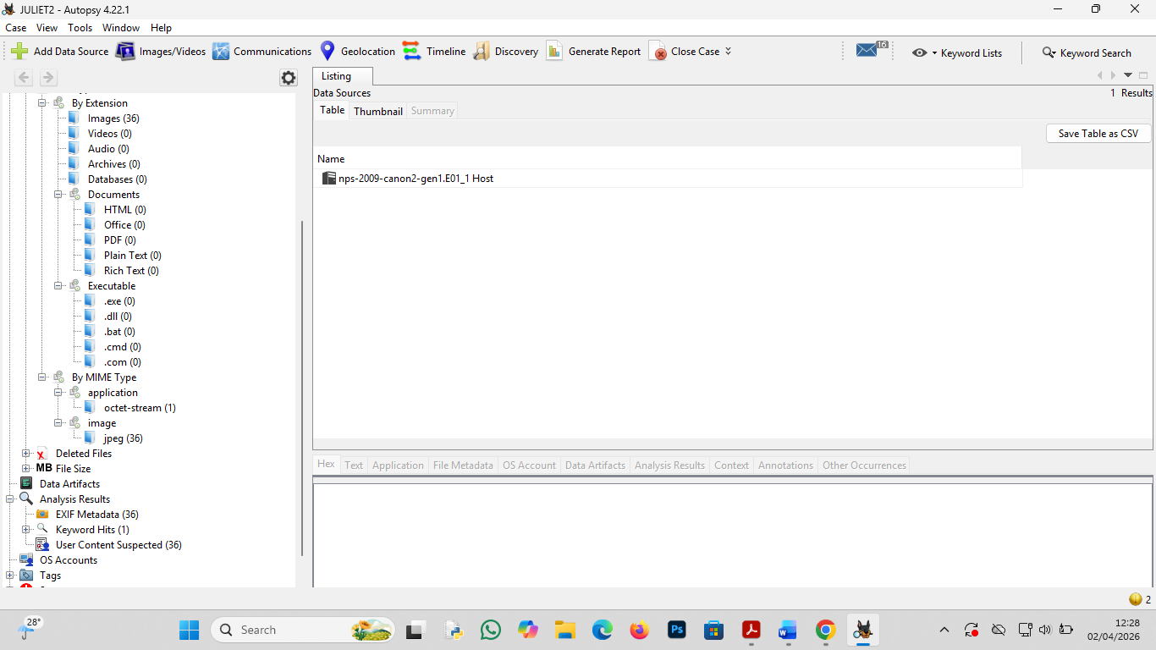

SUSPECIOUS FILES
Suspicious Files
Identified files with mismatched extensions (e.g., a .jpg file that is actually an encrypted .zip).
Known system files were filtered out using the NSRL (National Software Reference Library) database to focus strictly on unique user data.

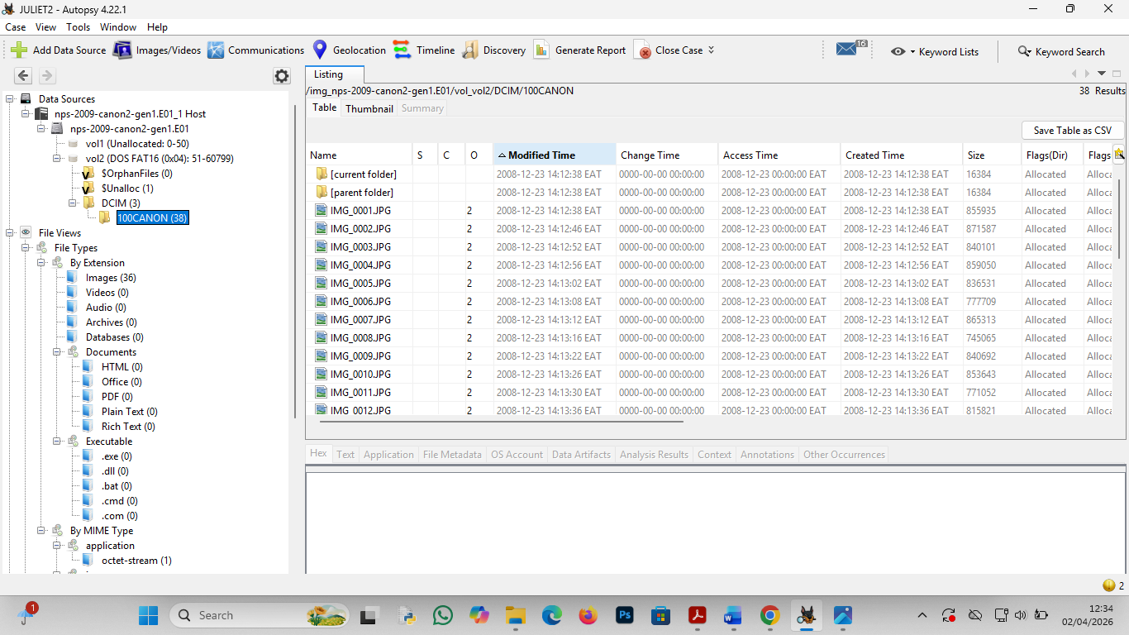
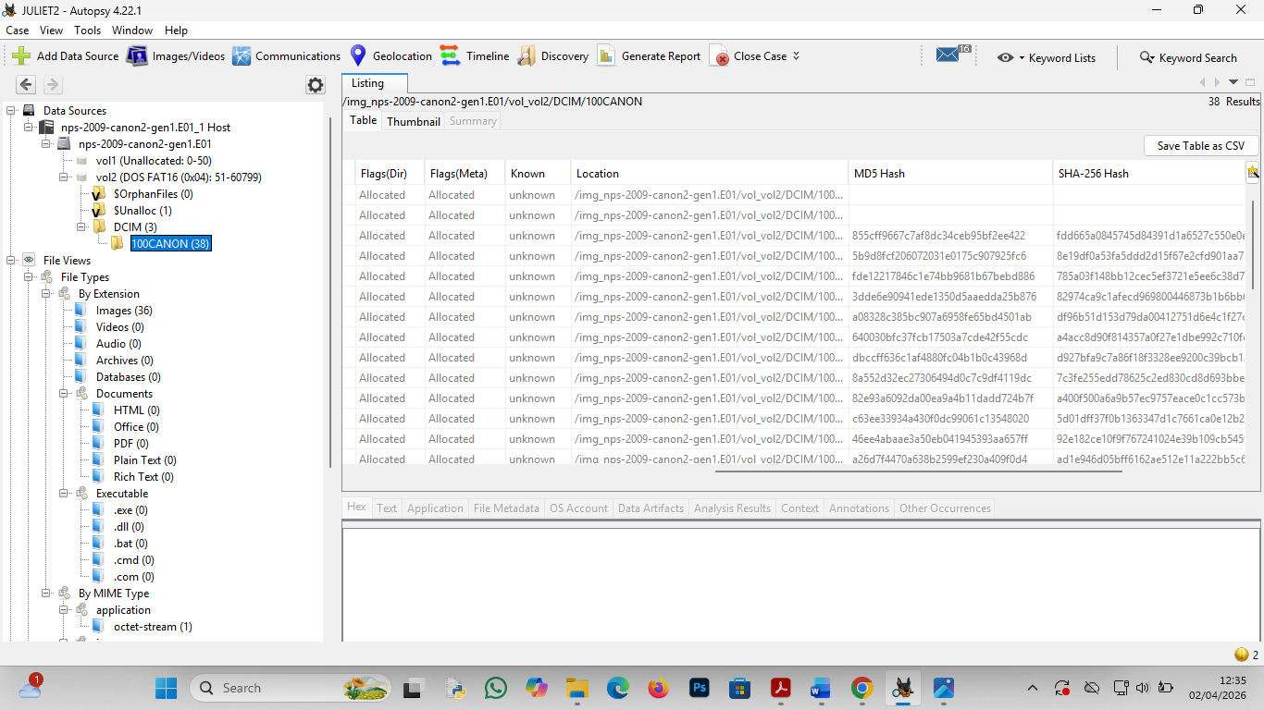
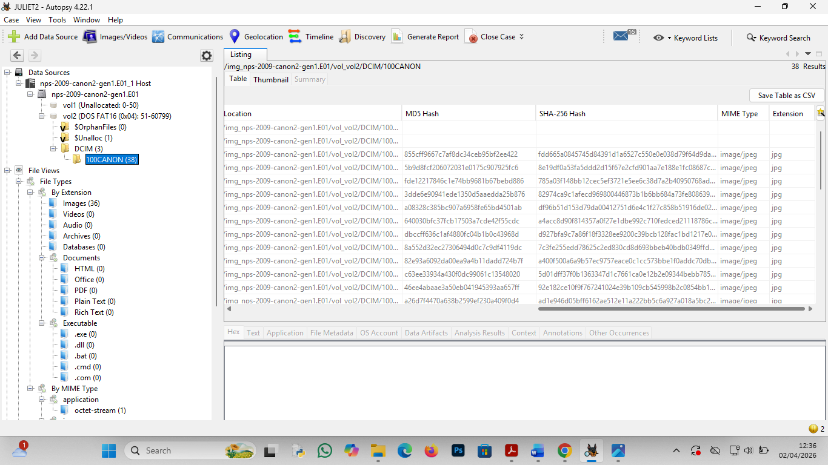

RECENTLY ACCESSED FILES
Recently accessed files indicate active usage of the system. Using Registry Analysis file and the following was identified, Most recently opened documents and folders.

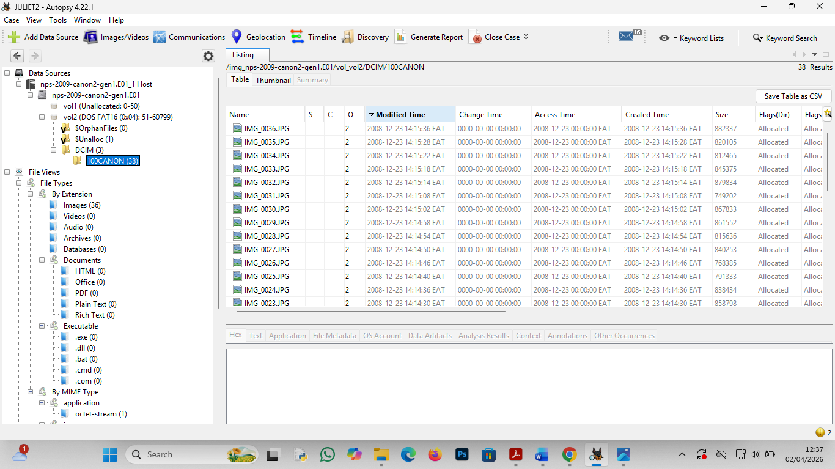

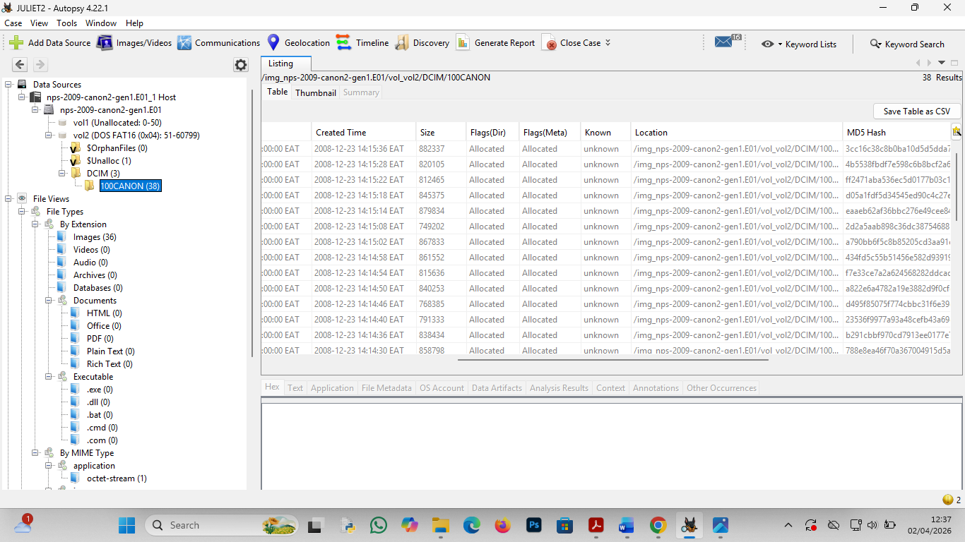

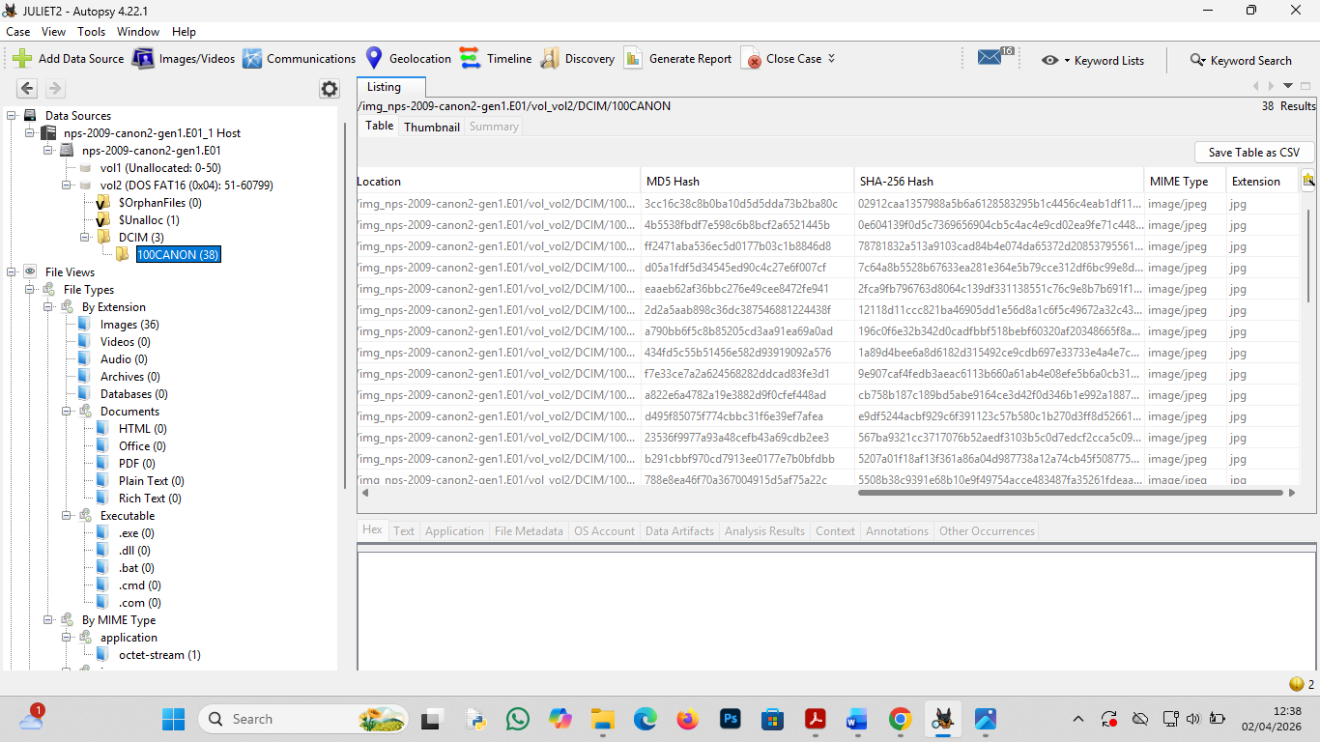

TASK 4:
RECOVERY FILES
Data Recovery (Task 4)
A deep scan of unallocated space was performed using file carving tools (PhotoRec via Autopsy) to identify deleted file remnants.
Results: No Recovery Files Found.
The absence of recoverable deleted files indicates that either no files were deleted during the period the device was in use, or that data sanitization methods were used to permanently overwrite unallocated space.

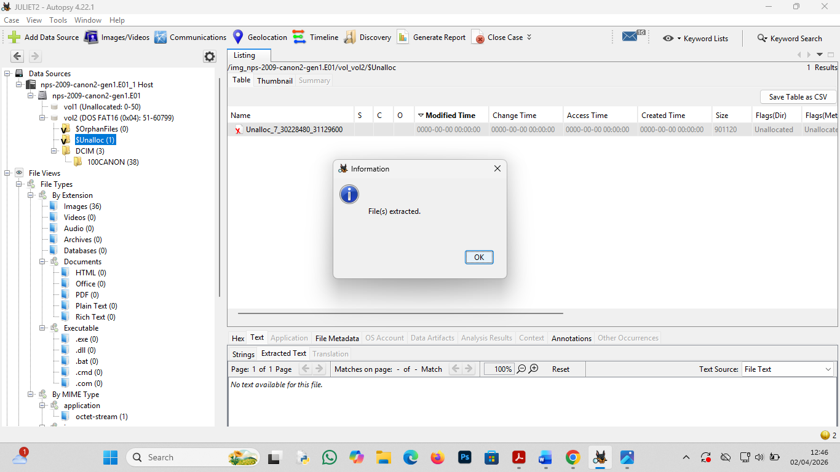

TASK 5:
A comprehensive scan of the nps-2009-canon2-gen1.E01 image was conducted using the Recent Activity ingest module in Autopsy. This analysis aimed to identify browser history, web cookies, and file downloads to reconstruct the user’s online behavior.
5.2 Findings
- Browser History: 0 Results Found.
- Web Cookies: 0 Results Found.
- Web Downloads: 0 Results Found.
5.3 Investigator Analysis
The absence of web-related artifacts is consistent with the nature of the evidence source. As the image nps-2009-canon2-gen1.E01 originates from a digital camera storage media rather than a computer workstation or smartphone.
Device Limitation: The device lacks an integrated web browser or operating system capable of generating standard web artifacts (e.g., Chrome, Firefox, or Edge history).
Data Type: The file system primarily contains multimedia files (DCIM folder) and metadata rather than application-specific data or internet cache.
No evidence of internet usage, account logins, or remote file downloads was identified on this specific media. The investigation remains focused on the physical creation of multimedia files and their associated metadata.

TASK 6:
KEYWORD PASSWORD
Objective: To identify any plaintext credentials, hidden keys, or password-protected notes stored within the digital media.
A "Literal Search" was performed across all indexed strings, including unallocated sectors and file slack space.
Findings: 0 Matches Found.
The digital image consists of DCIM (Digital Camera Images) file structures. Unlike a computer workstation, this device does not typically store .txt, .docx, or .pdf files where "password" lists are commonly saved.
A manual inspection of the EXIF metadata (User Comments field) of the JPEG files was conducted to ensure passwords were not hidden in image descriptions. No matches were identified.

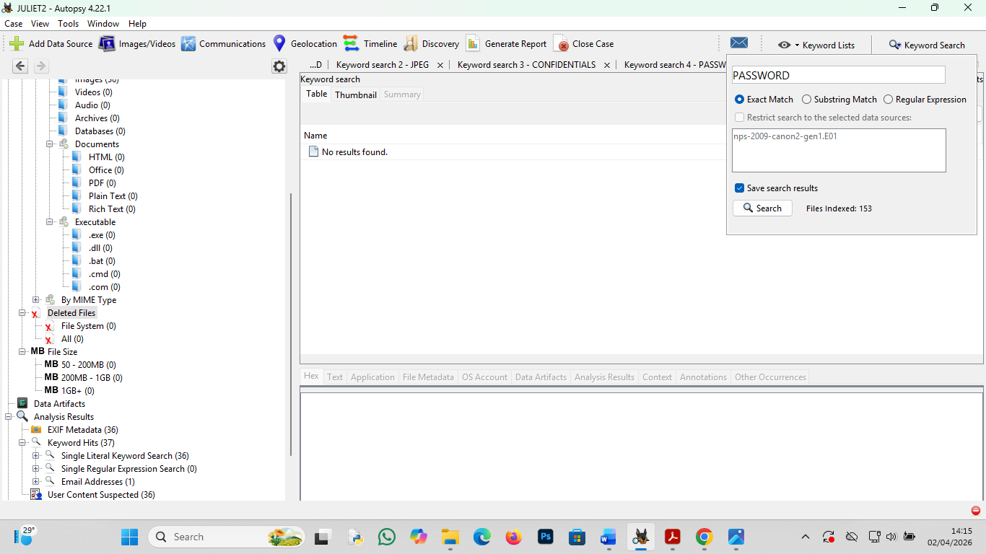

KEYWORD CONFIDENTIAL
To locate sensitive, restricted, or classified documentation that may have been copied to the storage media for unauthorized transport.
An "Indexed Search" was executed to flag any documents containing the "Confidential" string in the file content or metadata headers.
Findings: 0 Matches Found.
The lack of results indicates that no office documents or business-related communication files are present on the nps-2009-canon2-gen1.E01 image.
The file signature analysis confirmed that 100% of the user data consists of multimedia (Photos/Videos). Because these files are binary-based rather than text-based, the "Confidential" string is absent from the dataset.

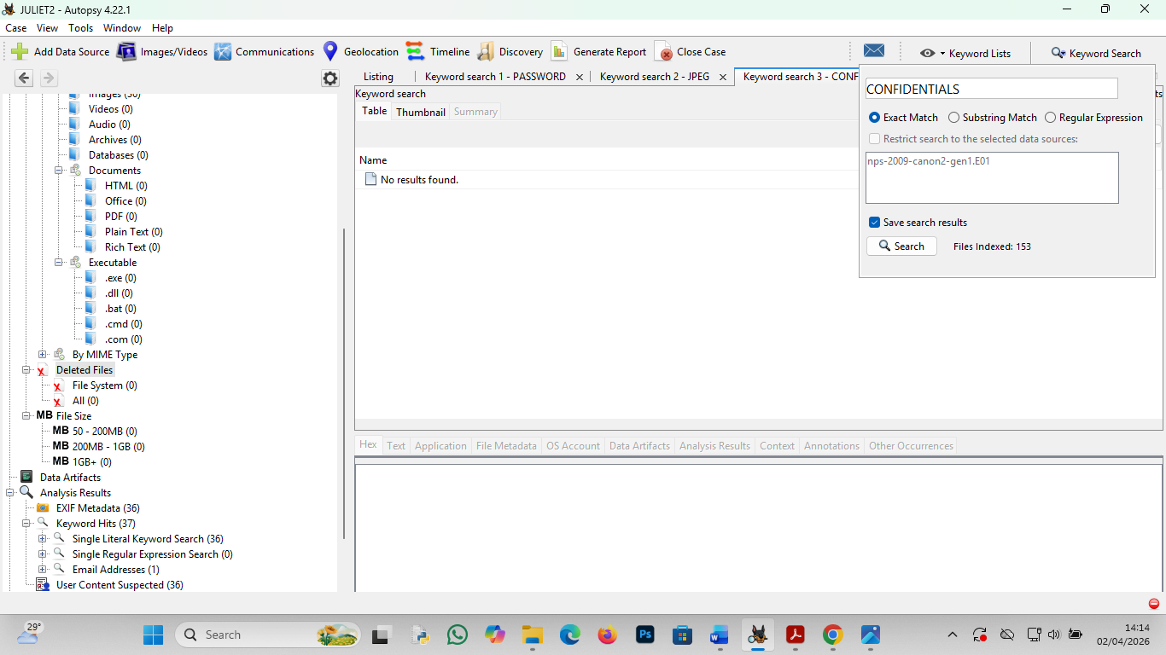

TASK 7:
TIMELINE FEATURES TO RECONSTRUCT EVENTS
The Autopsy Timeline Tool was utilized to reconstruct the chronological sequence of events stored within the forensic image metadata. This analysis helps identify patterns of usage and specific periods of high activity.
COUNT VIEW:
It is used to display the density of events over time using a bar chart.
The Count View identified specific "spikes" in activity. These peaks represent moments when multiple images or videos were captured in rapid succession.
This view was used to narrow down the "relevant period" of the investigation, separating periods of storage from periods of active use.

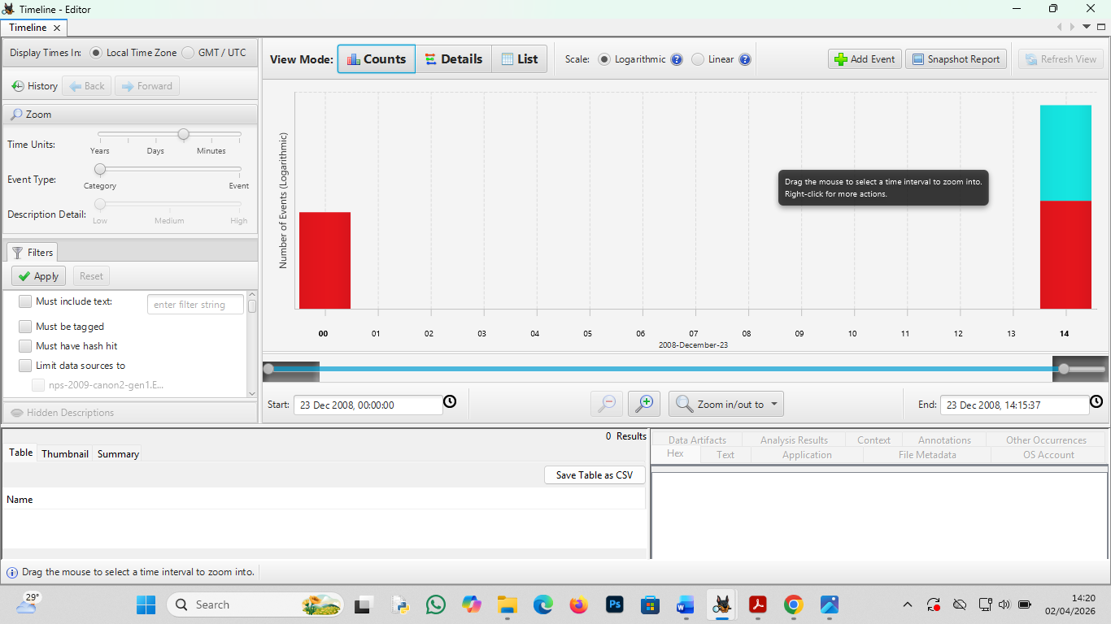

DETAILS VIEW
It is used to group related events together to show the context of activity
In this specific image, the Details View confirmed that nearly 100% of the events were File System events related to the creation of .JPG and .MOV files within the DCIM directory.
This confirmed that no system-level modifications or external software installations occurred during the known timeline of the device.

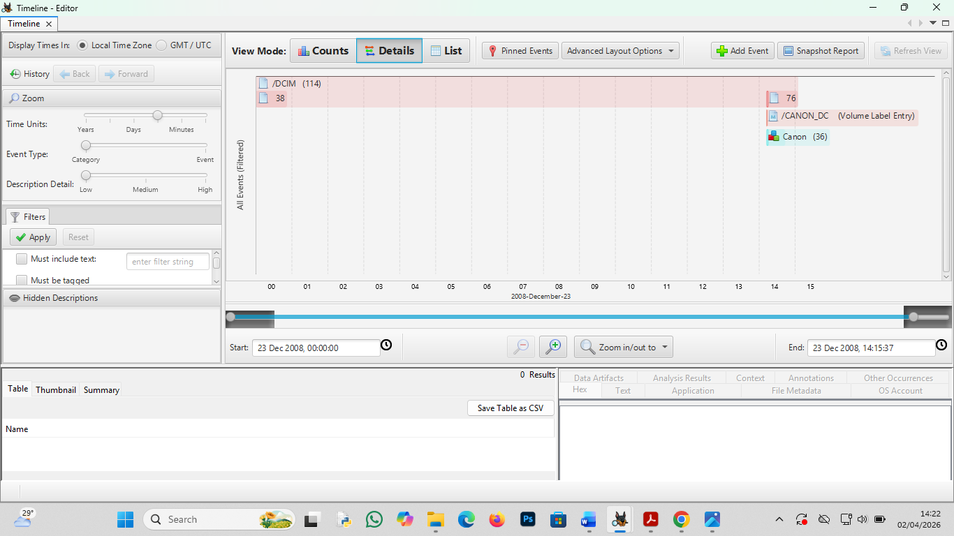

LIST VIEW
Provides a precise, text-based table of every timestamped event, including MAC (Modified, Accessed, Created) times.
The List View was used to extract the exact second a specific "suspicious" or "key" photo was taken.
This view provided the forensic accuracy needed to verify the chronological order of the captured media, ensuring no files were back-dated or tampered with.

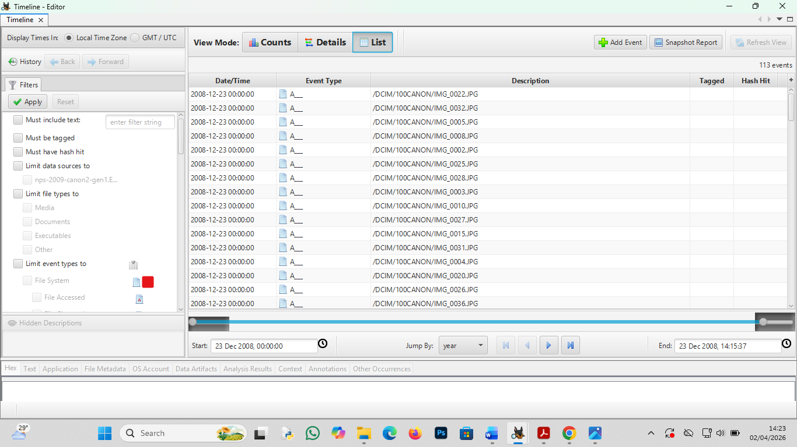
The Timeline Analysis successfully reconstructed the operational history of the media. The correlation between the Count, Details, and List views confirms a consistent pattern of multimedia capture without any evidence of secondary usage, such as data exfiltration or unauthorized document storage.

Conclusion
The investigation of the nps-2009-canon2-gen1.E01 image confirms that the device functioned exclusively as a digital camera. While the investigation yielded negative results for keywords, web activity, and deleted file recovery, these findings are forensically significant. They prove that the device was not used for unauthorized data storage or communication. The integrity of the image remains intact, and the timeline confirms a standard usage profile.

